**Wireshark Task 2**

**Part 1:**

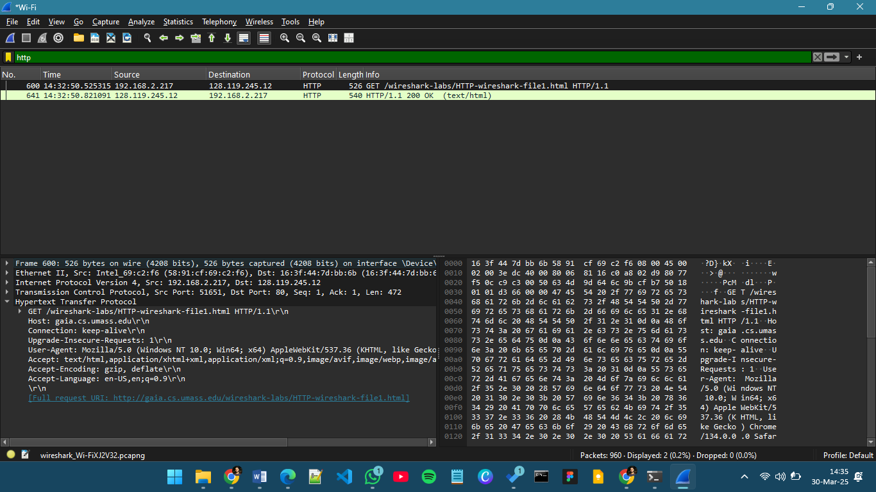

**Questions:**

1. **Is your browser running HTTP version 1.0, 1.1, or 2? What version of HTTP is the server running?**

1.1

1. **What languages (if any) does your browser indicate that it can accept to the server?**

Accept-Language: en-us,en;q=0.9

1. **What is the IP address of your computer? What is the IP address of the gaia.cs.umass.edu server?**

My Computer's IP Address: 192.168.2.217

Gaia.cs.umass.edu Server's IP Address: 128.119.245.12

1. **What is the status code returned from the server to your browser?**

200 OK, which indicates a successful request.

1. **When was the HTML file that you are retrieving last modified at the server?**

Sun, 30 Mar 2025 05:59:01 GMT

1. **How many bytes of content are being returned to your browser?**

540 bytes

1. **By inspecting the raw data in the packet content window, do you see any headers within the data that are not displayed in the packet-listing window? If so, name one.**

Date

**Part 2**

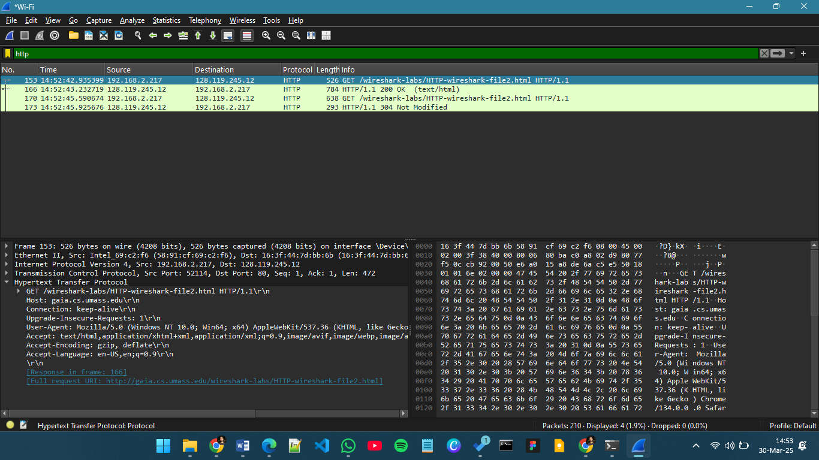

**Questions:**

1. **Inspect the contents of the first HTTP GET request from your browser to the server. Do you see an “IF MODIFIED-SINCE” line in the HTTP GET?**

No

1. **Inspect the contents of the server response. Did the server explicitly return the contents of the file? How can you tell?**

Yes, because the status code is followed by the return type, which says text/html

1. **Now inspect the contents of the second HTTP GET request from your browser to the server. Do you see an “IF-MODIFIED-SINCE:” line in the HTTP GET2? If so, what information follows the “IF MODIFIED-SINCE:” header?**

Yes, it contains the same time and date of modification as previous request

1. **What is the HTTP status code and phrase returned from the server in response to this second HTTP GET? Did the server explicitly return the contents of the file? Explain.**

Status Code: 304 Not modified. There is not any return type that follows the status code, thus server is not explicitly returning the content.

**Part 3**

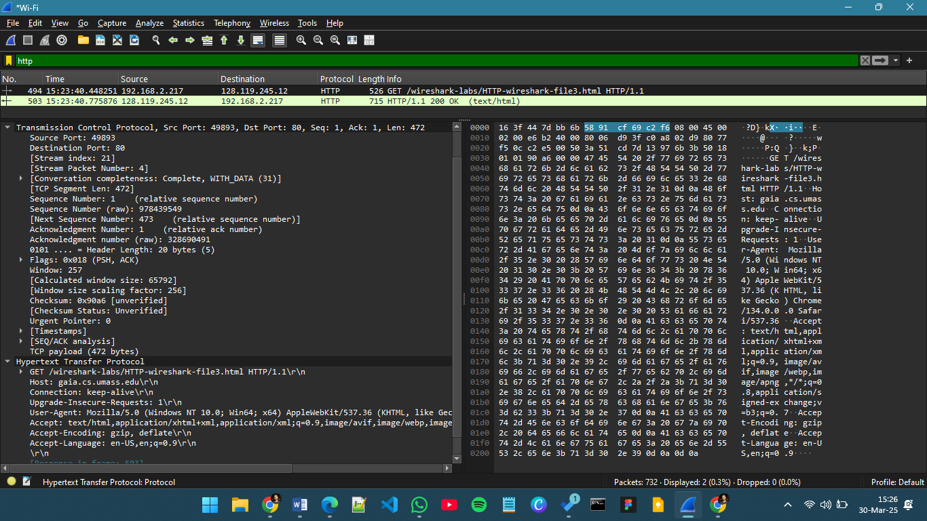

**Questions:**

1. **How many HTTP GET request messages did your browser send? Which packet number in the trace contains the GET message for the Bill or Rights?**

1, Packet 494

1. **Which packet number in the trace contains the status code and phrase associated with the response to the HTTP GET request?**

Packet 503, Status code 200 OK (text/html)

1. **What is the status code and phrase in the response?**

Status code 200 OK

1. **How many data-containing TCP segments were needed to carry the single HTTP response and the text of the Bill of Rights?**

3

**Part 4**

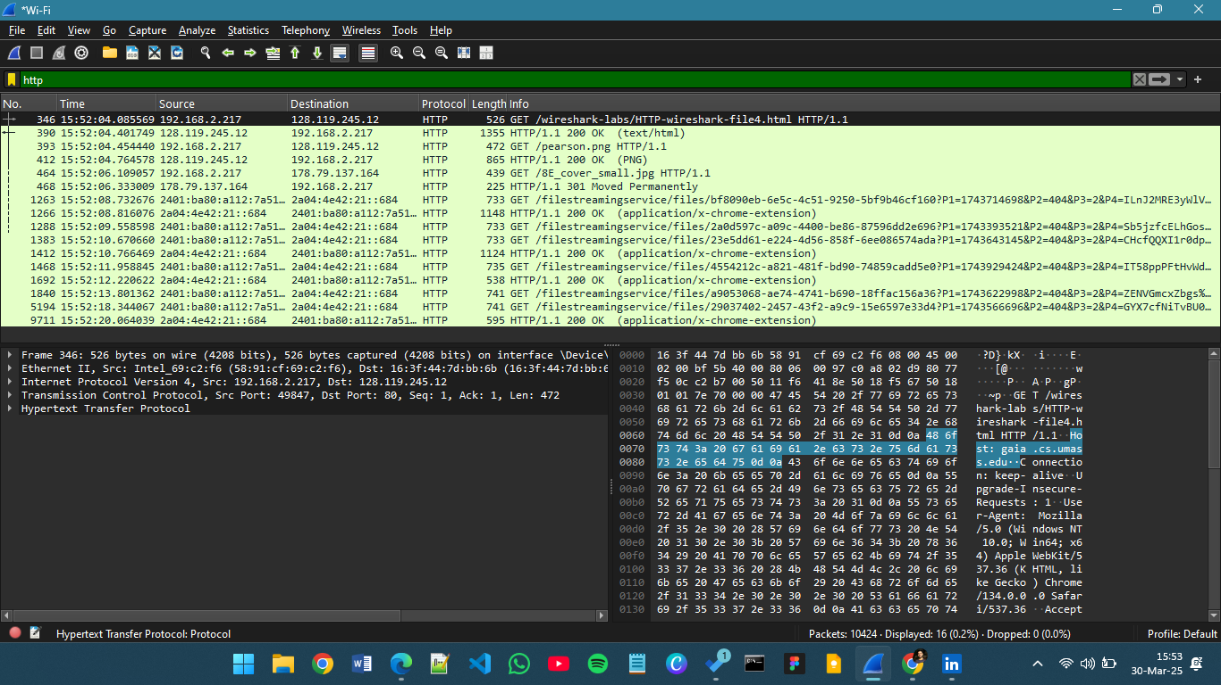

**Questions:**

1. **How many HTTP GET request messages did your browser send? To which Internet addresses were these GET requests sent?**

8

1. **Can you tell whether your browser downloaded the two images serially, or whether they were downloaded from the two web sites in parallel? Explain.**

Serially, because the request timestamp of second image is after the first image request is completed.

**Part 5**

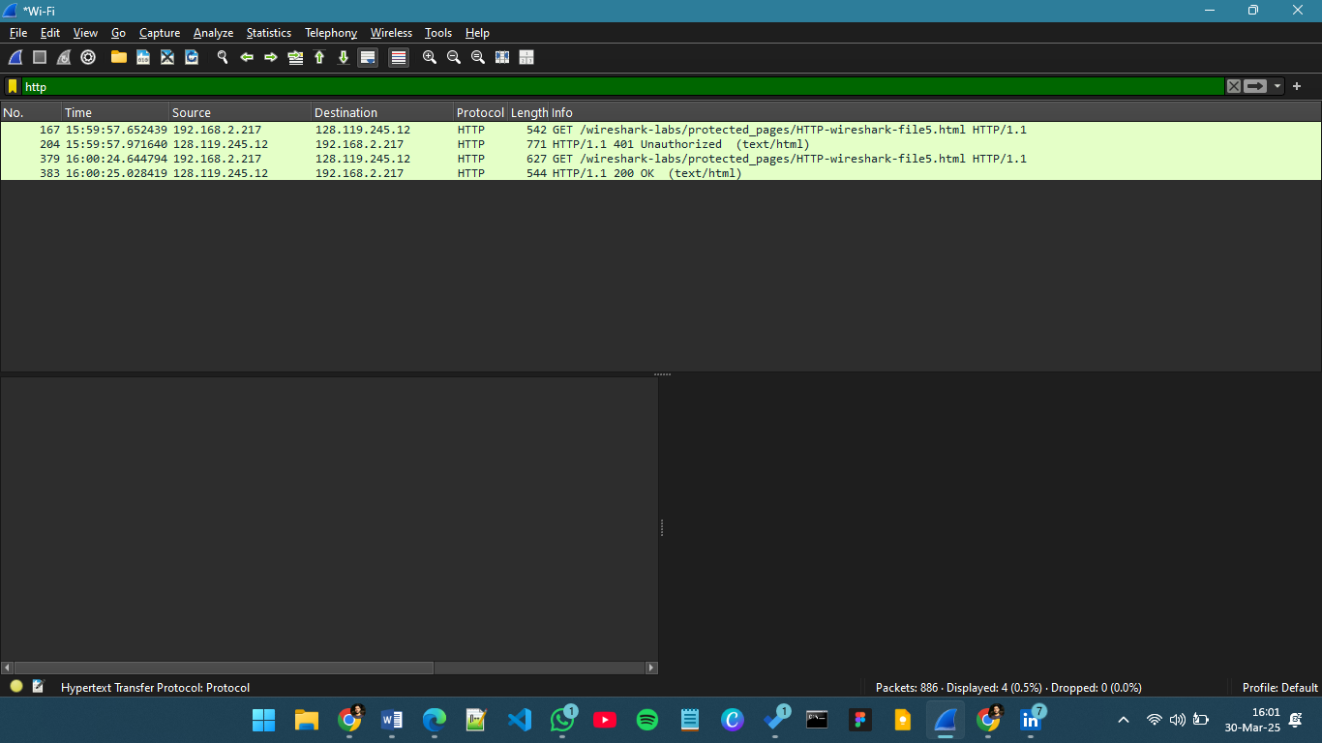

**Questions:**

1. **What is the server’s response (status code and phrase) in response to the initial HTTP GET message from your browser?**

Status Code: 401, Phrase: Unauthorized

1. **When your browser’s sends the HTTP GET message for the second time, what new field is included in the HTTP GET message?**

the new field is the Authorization header.